Learn Online Anytime Resources Guide
How to Access eLearning Resources for Your Development in sccLearn
Link: Resources for You (and Your Team's) Development

Aspire Journeys
Journeys are organized by topic area within the sccLearn Library. To browse through the Journey options, go to the Library, select Learning Bundles, and select one of the topic areas to browse the associated Aspire Journeys offered.
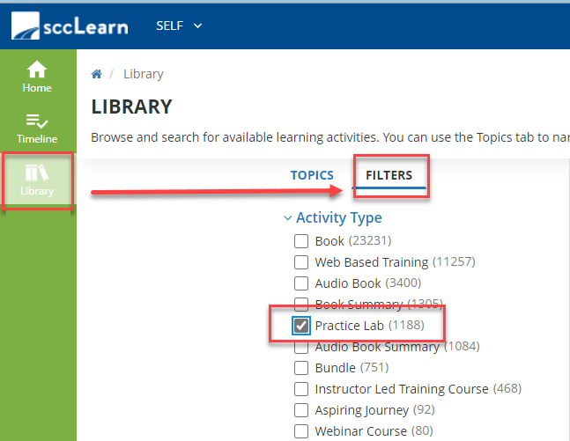

Books, Audiobooks, and Book Summaries
sccLearn provides on-demand, instant access to thousands of best-in-class books on many topics. Many books come in several forms including online books, book summaries, audiobooks, and audiobook summaries.
In sccLearn, you can simply search by title, topic, or author. Then, you can narrow your search by a format type that is best suited to your needs.
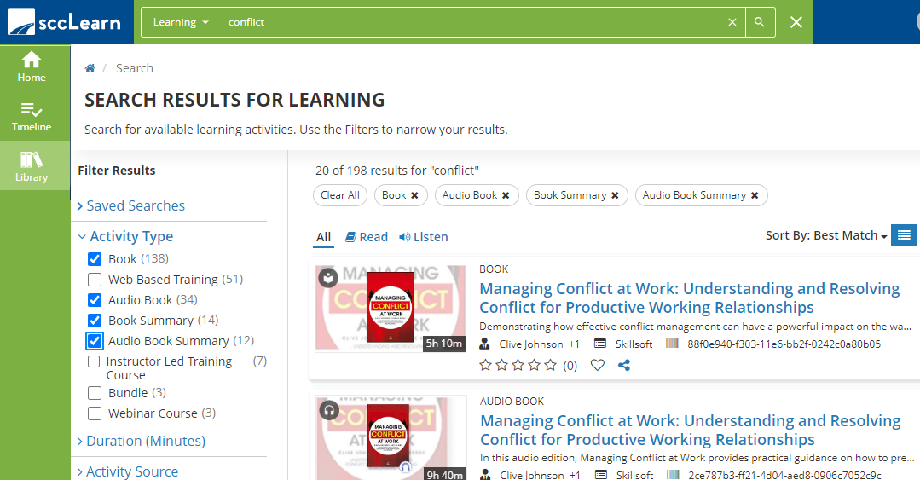

Continuing Education Units (CEUs) and Professional Development Units (PDUs)
sccLearn’s eLearning web-based trainings are recognized by various professional organizations as approved continuing education (CEU) or professional development (PDU) courses to maintain professional certifications with organizations such as the Project Management Institute (PMI) and the Board of Registered Nursing (BRN).
Each organization has their own process for learners to submit a certificate of completion on equivalent courses for their programs. To learn more, navigate to the Continuing Education Units (CEUs) & Professional Development Units (PDUs) accordion menu and then select the organization of interest.
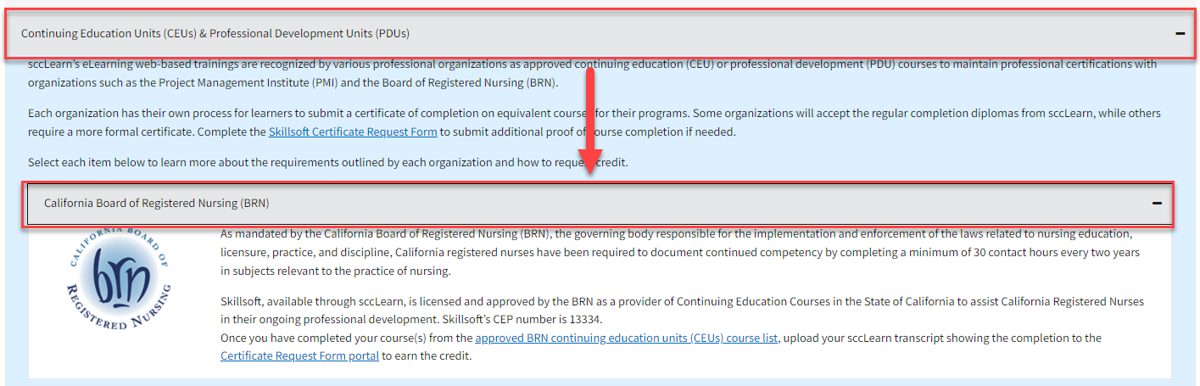

Learning Bundles
Learning Bundles are curated training activities in sccLearn focused around one topic area to hone your skills. Learning Bundles contain web-based courses, books, audiobooks, practice labs, or Skill Benchmarks. Some Learning Bundles allow you further narrow content by version and expertise level.
Access Learning Bundles in sccLearn from the sccLearn Library and then selecting Learning Bundles.
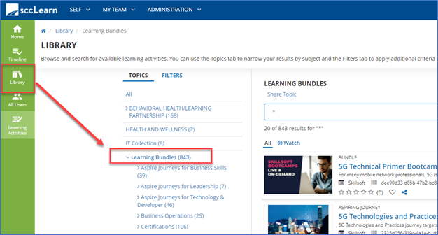

Practice Labs
To access a Practice Lab, navigate to the Library > Filters option > Select Practice Lab to show all available options.

Skill Benchmarks
Skill Benchmarks can be found within Learning Bundles associated with a given topic. To access a Skill Benchmark, select Assess under the activities options of a Learning Bundle.
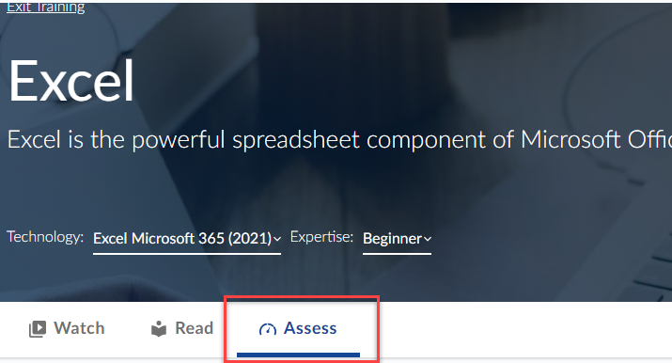

Skillsoft Live Bootcamps and Leadercamps
Skillsoft Live Camps include Bootcamps and Leadercamps and are available either as live offerings or recorded sessions. To discover Skillsoft Live Camps, navigate to the Library > Learning Bundles > Select either Skillsoft Bootcamps or Skillsoft Leadercamps.
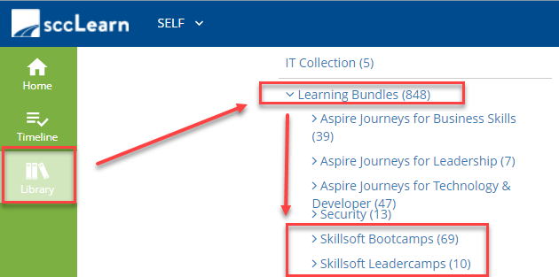

Both Skillsoft Bootcamps and Skillsoft Leadercamps are organized by topic area. Here all past and future (Live) camps that are associated with that topic can be accessed in one place.
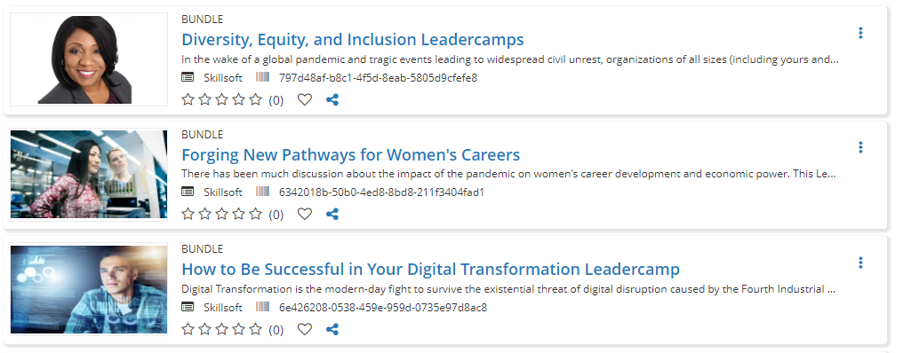

Skillsoft Live and On-Demand Events
Live Events and their corresponding recordings are keynote presentations delivered by industry experts, thought leaders, and best-selling authors.
Accessing Live and On-Demand Events:
From the Library: Navigate to Learning Bundles > Skillsoft Live Events> Select either On-Demand (Recordings of Previously Held events) or Upcoming (Live) Events
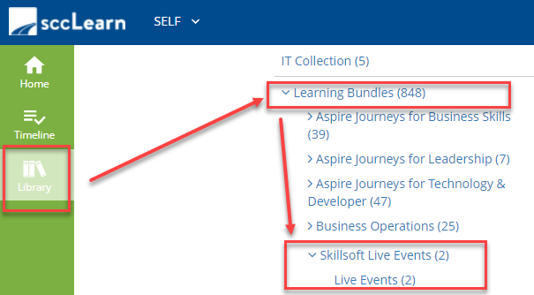
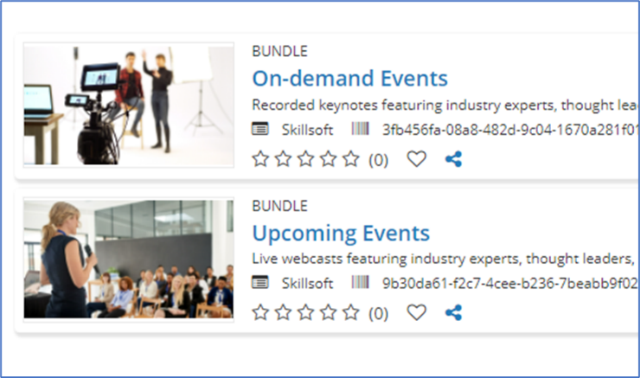

Test Prep and Certification
Test Preps can be found through the sccLearn Library > select Filters > check the Test Prep Box.
To find information on certifications and certification-aligned courses, go to the “Test Prep and Certification” accordion drop-down. Search for and download the Certification Matrix to view a list of courses relevant to the certification of interest.

Web-Based Courses
sccLearn provides access to 100’s of web-based training courses that you can complete at your own convenience. The courses are designed to be engaging and interactive and many contain videos to enhance the topic. Courses typically have a duration of 20-90 minutes, however, you don’t need to complete the whole training – you can look at the menu provided in the course and hone into the section or video that can provide you with the quick “just in time” learning you are looking for.
Simply type the topic into the sccLearn search field and browse to find the course that best meets your needs.

Please share these resources with your colleagues and don’t hesitate to reach out to LED if you have questions at LED@ceo.sccgov.org.

